Copyright for test papers and marking guides remains with *West Australian Test Papers.*

Test papers may only be reproduced within the purchasing school according to the advertised Conditions of Sale.

Test papers should be withdrawn after use and stored securely in the school until Wednesday June 22nd 2018.



**MATHEMATICS**

**SPECIALIST**

**UNIT 1**

**Semester One**

**2018**

**SOLUTIONS**

***Calculator−free Solutions***

1. (a) ✓

✓✓

(b) (i) ✓

(ii) ✓

✓

OR

✓

✓ [6]

2. (a) (i) ✓

✓

(ii) ✓

✓

(b) LHS ✓

✓

✓✓

RHS (Or from RHS to LHS) [8]

3. (a) but is false ✓

(b) “If the triangle is not equilateral, then the triangle does not

have three equal sides.” ✓

Yes is it always true since the original implication is always

true by definition of equilateral triangles. ✓

(c) “If n is divisible by 3, then n is divisible by 6”. ✓

The converse is not always true, because for n to be

divisible by 6 is must be divisible by both 2 and 3. ✓

(d) FOR ALL natural numbers p, EXISTS a real number q, ✓✓

such that q is the square root of p. [7]

4. (a) ✓

✓

✓

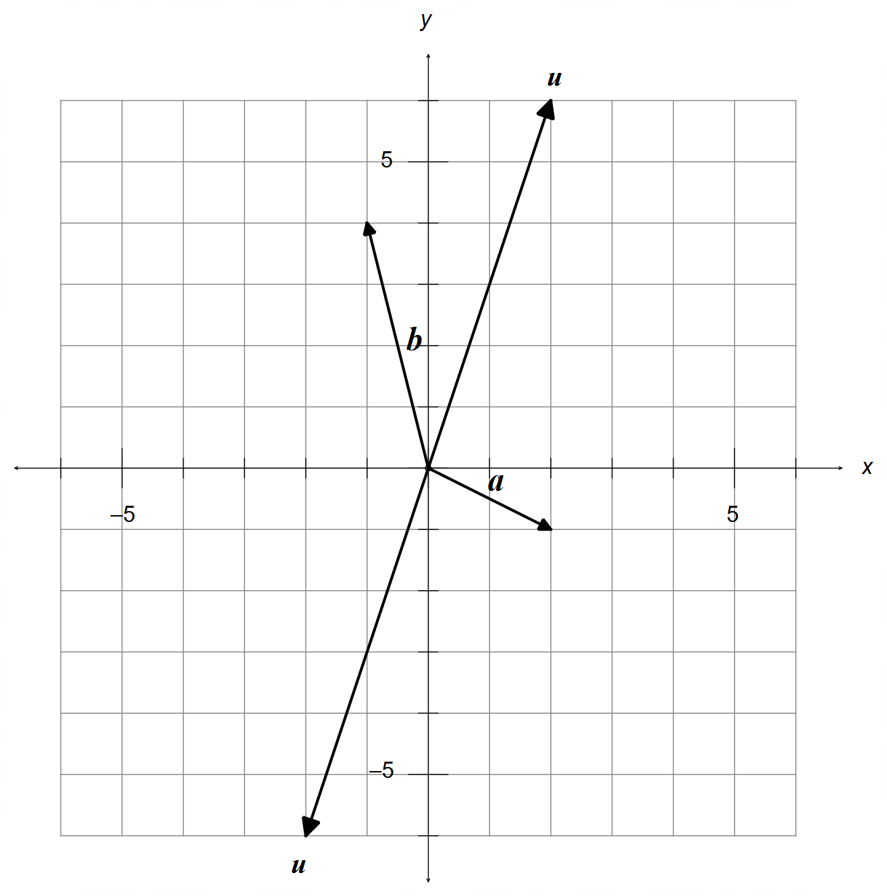

✓

(b) (i) ✓

✓

(ii)

✓

✓

✓✓ [10]

5. (a) ✓

✓

✓

OABC is a rhombus

(b) LHS ✓

✓

✓

✓

as required [7]

6. (a) ∠AED = 90° ✓

Triangle in a semi-circle is always right angled. ✓

(b) ∠ABE = ∠ADE = 60° ✓

Angles within the same segment are congruent. ✓

(c) ∠CAE = 80° ✓

Opposite angles in a cyclic quadrilateral are supplementary ✓

(d) ∠TCE = ∠CBE = 100° ✓

The alternate segment theorem. ✓ [8]

7. ✓

✓

and ✓✓ [4]

***Calculator−assumed Solutions***

8. (a) Assume all non-repeated numbers are selected from

both sets: 3, 8, 4, 6 = 4 digits✓

Plus all remaining digits from one set: 1, 2, 5, 7 = 4 digits

Plus one more digit to make the first repetition

$∴$ 4 + 4 + 1 = 9 digits minimum ✓

(b) Assume the largest numbers are chosen first: ✓

8 + 7 + 7 + 6 = 28 ✓

one more digit could include the number 5, making

the sum over 30.

$∴$ 4 digits max ✓ [54

9. (a) (i) ✓

(ii) ✓✓

(iii) ✓✓

(iv) ✓✓

(b) (i) ✓

(ii) ✓✓

(iii) ✓✓ [12]

10. (a) II and III ✓✓

(b) OR ✓✓✓

(c) LHS ✓

✓

✓

✓

✓

RHS [10]

11. (a) (i) ✓

(ii) ✓

(iii) ✓

(iv) ✓

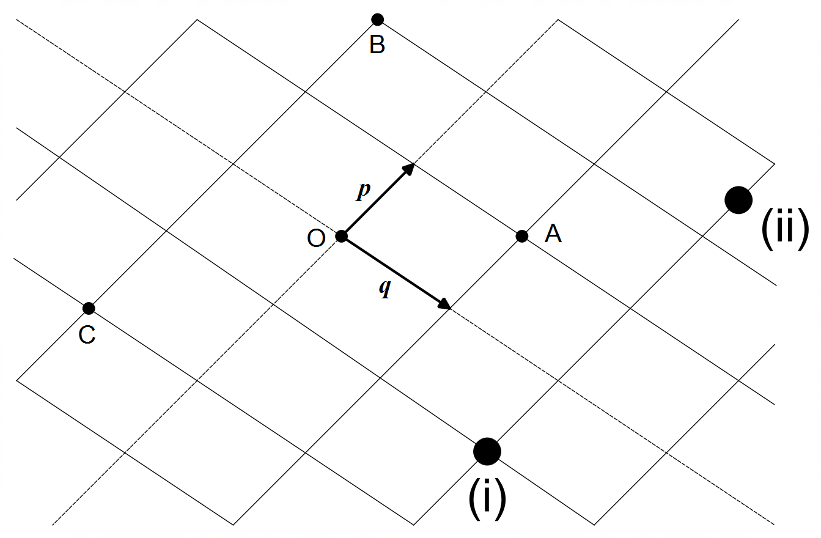 (b)

✓✓

[6]

12. (a) ✓

✓

(b)

✓

✓

(c) ✓

(d)

✓

✓

∠CDB is right angled [7]

13. (a) (i) True. ✓

If a number is divisible by 6, then it is also divisible

by both 2 and 3. ✓

(ii) False. ✓

It must be divisible by both 2 and 3. ✓

(iii) True. ✓

The conjunction AND means that it is divisible by both

2 and 3, and therefore it is also divisible by 6. ✓

(b) Assume that $n$ is odd AND that $3n+5$ is also odd ✓

such that ✓

✓

even ✓

Since $3n+5$ is both odd and even simultaneously, this is

a contradiction, implying that $n$ must be even. ✓

(c)

✓✓✓

✓ [15]

14. (a) ✓

✓

(b)

✓✓

✓✓

(c) If then ✓

Cable 2 exceeds its maximum load, hence Cable 1

must not reach its 200N maximum rating ✓

If $F_{2}=200N$ then ✓✓

Max Force ✓

✓ [12]

15. (a) ✓

✓

✓

(b)

✓

✓

✓ [6]

16. (a) ✓

✓

(b) ✓

✓

(c) ✓✓

(d) ✓✓ [8]

17. (a) ✓

✓

(b) ✓

✓

✓

✓

DEFG is a parallelogram ✓ [7]

18. ✓

✓

✓

✓

✓

✓ [6]

19. Let be a unit vector perpendicular to $b$

then, ✓

✓

let ✓

✓

and ✓✓ [6]